Online Flight Reservation System
1. Aim
To design and develop an Online Flight Reservation System using HTML, CSS, and other suitable programming languages to allow users to search flights, book tickets, make payments, view booking status, cancel tickets, and print e-tickets. It also provides an admin interface to manage flight schedules, seat availability, fares, customer details, and reports.
2. Software Required
- Operating System: Windows
- Front-end Technologies: HTML5 and CSS3
- Programming Language: JavaScript / PHP
- Database: MySQL
- Code Editor: Visual Studio Code
- Web Browser: Google Chrome
3. Algorithm
- Start the program and create the flight reservation website using HTML and CSS.
- Design the administrator login and forgot password pages.
- Create a flight search form to enter source, destination, journey date, and travel class.
- Display available flights, schedules, fares, and seat availability.
- Create ticket booking and passenger details forms.
- Design the payment page and generate booking confirmation and e-tickets after successful payment.
- Create pages to view booking status, access and print tickets, cancel tickets, and submit customer feedback.
- Develop an admin dashboard to manage flights, seats, fares, users, and reports; connect the pages to a database and test the system.

2. index.html

<!DOCTYPE html>
<html>
<head>
<title>Online Flight Reservation System</title>
<link rel="stylesheet" href="style.css">
</head>
<body>
<header>
<h1>SkyWay Flight Reservation</h1>
<p>Book your journey with ease</p>
</header>

<nav>
<a href="#search">Search Flights</a>
<a href="#booking">Book Ticket</a>
<a href="#tickets">My Tickets</a>
<a href="#cancel">Cancel Ticket</a>
<a href="#feedback">Feedback</a>
<a href="#admin">Admin</a>
</nav>

<section id="search">
<h2>Search Flights</h2>
<form id="flightForm">
<label>From:</label>
<input id="from" placeholder="Departure city" required>

<label>To:</label>
<input id="to" placeholder="Destination city" required>

<label>Travel Date:</label>
<input type="date" id="date" required>

<label>Travel Class:</label>
<select id="class">
<option>Economy</option>
<option>Business</option>
<option>First Class</option>
</select>

<button type="submit">Search Flights</button>
</form>
<div id="results"></div>
</section>

<section id="booking">
<h2>Book Ticket</h2>
<form id="bookingForm">
<label>Flight Number:</label>
<input id="flightNo" placeholder="Example: SW101" required>

<label>Passenger Name:</label>
<input id="passenger" required>

<label>Passenger Age:</label>
<input type="number" id="age" min="1" max="120" required>

<label>Seat Number:</label>
<input id="seat" placeholder="Example: 12A" required>

<label>Payment Method:</label>
<select id="payment">
<option>UPI</option>
<option>Credit/Debit Card</option>
<option>Net Banking</option>
</select>

<button type="submit">Pay and Book</button>
</form>
<p id="bookingMessage"></p>
</section>

<section id="tickets">
<h2>My Tickets / Booking Status</h2>
<button onclick="showTickets()">View My Tickets</button>
<div id="ticketList"></div>
<button onclick="window.print()">Print Ticket</button>
</section>

<section id="cancel">
<h2>Cancel Ticket</h2>
<form id="cancelForm">
<label>Booking ID:</label>
<input id="cancelId" required>
<button type="submit">Cancel Ticket</button>
</form>
<p id="cancelMessage"></p>
</section>

<section id="feedback">
<h2>Customer Feedback</h2>
<form id="feedbackForm">
<label>Your Name:</label>
<input id="feedbackName" required>

<label>Feedback:</label>
<textarea id="feedbackText" required></textarea>

<button type="submit">Submit Feedback</button>
</form>
<p id="feedbackMessage"></p>
</section>

<section id="admin">
<h2>Administrator Login</h2>
<form id="adminForm">
<label>Username:</label>
<input id="adminUser" required>

<label>Password:</label>
<input type="password" id="adminPass" required>

<button type="submit">Login</button>
</form>

<p id="adminMessage"></p>
<div id="adminReport"></div>
</section>

<footer>
<p>Online Flight Reservation System | Internet Programming Lab</p>
</footer>

<script src="script.js"></script>
</body>
</html>
3. style.css

body {
font-family: Arial, sans-serif;
margin: 0;
background: #eef3f8;
color: #222;
}

header {
background: #064789;
color: white;
text-align: center;
padding: 22px;
}

nav {
background: #032b50;
padding: 14px;
text-align: center;
}

nav a {
color: white;
text-decoration: none;
margin: 10px;
display: inline-block;
}

section {
background: white;
margin: 20px auto;
padding: 22px;
max-width: 700px;
border-radius: 8px;
box-shadow: 0 2px 8px #ccc;
}

h2 {
color: #064789;
}

label {
display: block;
margin-top: 12px;
}

input, select, textarea {
width: 100%;
padding: 10px;
margin-top: 5px;
box-sizing: border-box;
}

button {
background: #064789;
color: white;
border: none;
padding: 11px 16px;
margin-top: 15px;
cursor: pointer;
border-radius: 4px;
}

button:hover {
background: #087eae;
}

.result {
background: #eef7ff;
padding: 12px;
margin-top: 12px;
border-left: 4px solid #064789;
}

footer {
background: #032b50;
color: white;
text-align: center;
padding: 15px;
}

@media (max-width: 600px) {
nav a {
display: block;
}

section {
margin: 12px;
padding: 16px;
}
}
4. script.js

let flights = [
{ no: "SW101", from: "Chennai", to: "Delhi", fare: 4500, seats: 30 },
{ no: "SW202", from: "Chennai", to: "Mumbai", fare: 3500, seats: 25 },
{ no: "SW303", from: "Bengaluru", to: "Delhi", fare: 4000, seats: 20 },
{ no: "SW404", from: "Delhi", to: "Chennai", fare: 4200, seats: 18 }
];

let bookings = [];
let feedbacks = [];
let bookingCounter = 1001;

document.getElementById("flightForm").addEventListener("submit", function(e) {
e.preventDefault();

let from = document.getElementById("from").value.trim();
let to = document.getElementById("to").value.trim();
let date = document.getElementById("date").value;
let travelClass = document.getElementById("class").value;

let results = document.getElementById("results");
results.innerHTML = "";

let found = false;

flights.forEach(function(flight) {
if (flight.from.toLowerCase() === from.toLowerCase() &&
flight.to.toLowerCase() === to.toLowerCase()) {

found = true;
let fare = flight.fare;

if (travelClass === "Business") fare *= 2;
if (travelClass === "First Class") fare *= 3;

results.innerHTML += `
<div class="result">
<b>Flight:</b> ${flight.no}<br>
<b>Route:</b> ${flight.from} to ${flight.to}<br>
<b>Date:</b> ${date}<br>
<b>Class:</b> ${travelClass}<br>
<b>Available seats:</b> ${flight.seats}<br>
<b>Fare:</b> ₹${fare}<br>
<button onclick="selectFlight('${flight.no}')">
Book This Flight
</button>
</div>`;
}
});

if (!found) {
results.textContent = "No matching flights found.";
}
});

function selectFlight(flightNo) {
document.getElementById("flightNo").value = flightNo;
document.getElementById("booking").scrollIntoView();
}

document.getElementById("bookingForm").addEventListener("submit", function(e) {
e.preventDefault();

let flightNo = document.getElementById("flightNo").value.trim().toUpperCase();
let passenger = document.getElementById("passenger").value.trim();
let age = Number(document.getElementById("age").value);
let seat = document.getElementById("seat").value.trim().toUpperCase();
let payment = document.getElementById("payment").value;

let flight = flights.find(f => f.no === flightNo);

if (!flight) {
alert("Flight not found. Please search for a valid flight.");
return;
}

if (flight.seats <= 0) {
alert("Sorry, no seats are available.");
return;
}

let seatTaken = bookings.some(b =>
b.flightNo === flightNo &&
b.seat === seat &&
b.status === "Confirmed"
);

if (seatTaken) {
alert("This seat is already booked.");
return;
}

let booking = {
id: bookingCounter++,
flightNo: flightNo,
passenger: passenger,
age: age,
seat: seat,
payment: payment,
fare: flight.fare,
status: "Confirmed"
};

bookings.push(booking);
flight.seats--;

document.getElementById("bookingMessage").textContent =
"Booking successful! Booking ID: " + booking.id +
". Payment simulation completed using " + payment + ".";

document.getElementById("bookingForm").reset();
});

function showTickets() {
let list = document.getElementById("ticketList");
list.innerHTML = "";

if (bookings.length === 0) {
list.textContent = "No tickets booked yet.";
return;
}

bookings.forEach(function(b) {
list.innerHTML += `
<div class="result">
<b>Booking ID:</b> ${b.id}<br>
<b>Passenger:</b> ${b.passenger}<br>
<b>Flight:</b> ${b.flightNo}<br>
<b>Seat:</b> ${b.seat}<br>
<b>Fare:</b> ₹${b.fare}<br>
<b>Status:</b> ${b.status}
</div>`;
});
}

document.getElementById("cancelForm").addEventListener("submit", function(e) {
e.preventDefault();

let id = Number(document.getElementById("cancelId").value);
let booking = bookings.find(b => b.id === id);

if (!booking || booking.status !== "Confirmed") {
document.getElementById("cancelMessage").textContent =
"Booking not found or ticket already cancelled.";
return;
}

booking.status = "Cancelled";

let flight = flights.find(f => f.no === booking.flightNo);
if (flight) flight.seats++;

document.getElementById("cancelMessage").textContent =
"Ticket cancelled successfully. Refund processing is not connected to a real payment service.";
});

document.getElementById("feedbackForm").addEventListener("submit", function(e) {
e.preventDefault();

let name = document.getElementById("feedbackName").value;
let message = document.getElementById("feedbackText").value;

feedbacks.push({ name: name, message: message });

document.getElementById("feedbackMessage").textContent =
"Thank you for your feedback!";

document.getElementById("feedbackForm").reset();
});

document.getElementById("adminForm").addEventListener("submit", function(e) {
e.preventDefault();

let username = document.getElementById("adminUser").value;
let password = document.getElementById("adminPass").value;

if (username === "admin" && password === "admin123") {
document.getElementById("adminMessage").textContent =
"Admin login successful.";

document.getElementById("adminReport").innerHTML =
"<h3>Admin Report</h3>" +
"<p>Total bookings: " + bookings.length + "</p>" +
"<p>Confirmed tickets: " +
bookings.filter(b => b.status === "Confirmed").length + "</p>" +
"<p>Cancelled tickets: " +
bookings.filter(b => b.status === "Cancelled").length + "</p>" +
"<p>Customer feedback entries: " + feedbacks.length + "</p>";
} else {
document.getElementById("adminMessage").textContent =
"Invalid admin username or password.";
}
});
OUTPUT:
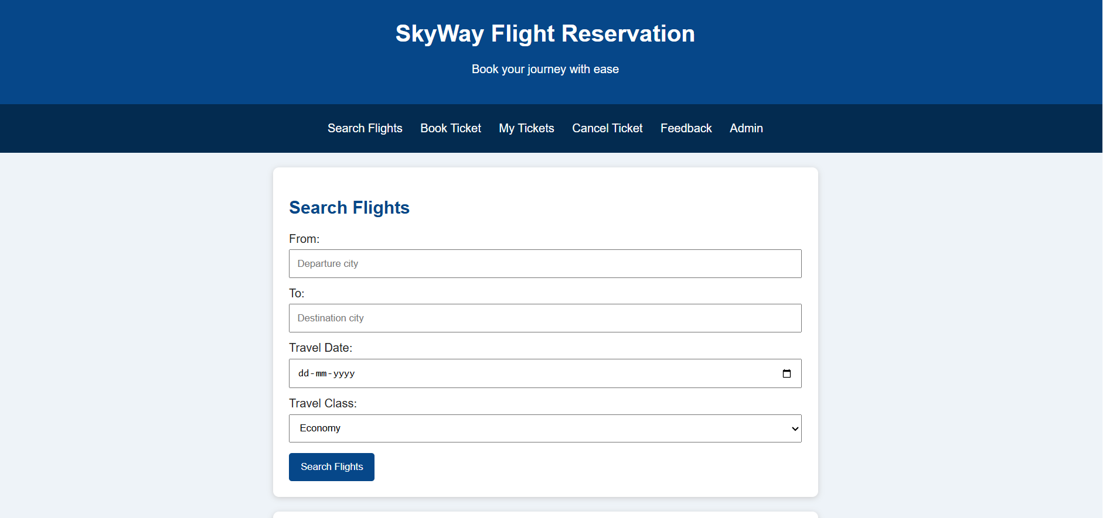
4. Result
Thus, the Online Flight Reservation System was designed using HTML, CSS, and other suitable technologies. The system provides interfaces for flight search, ticket booking, payment, booking status, ticket cancellation, e-ticket printing, and customer feedback. It also includes an administrator panel for managing flight information, seat availability, fares, users, and reports.

